**Experiment-7**

**Create pipeline using Blue Ocean Plugin**

**Step-1:** Start and login to Jenkins

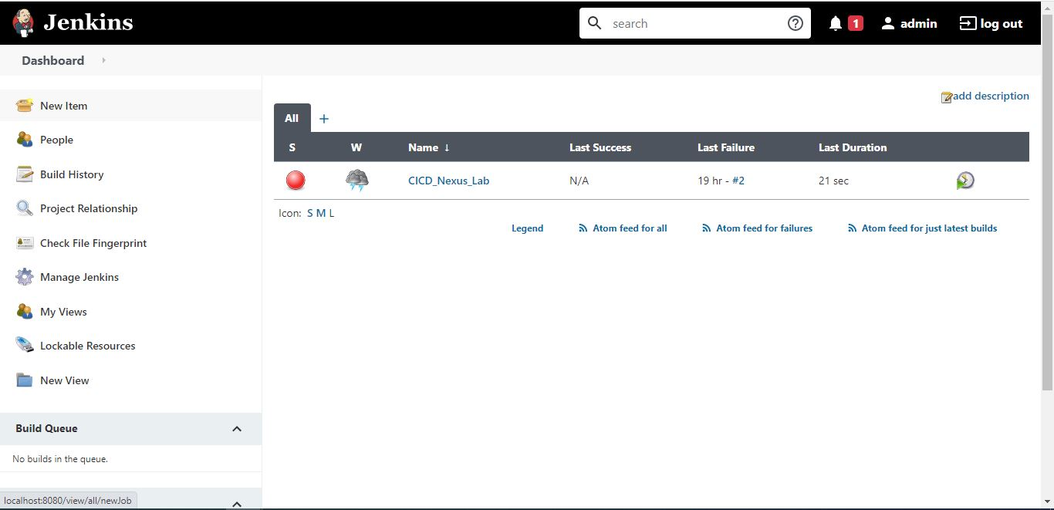

**Step-2:** Install Blue Ocean Plugin and will be able to see in on the dashboard.

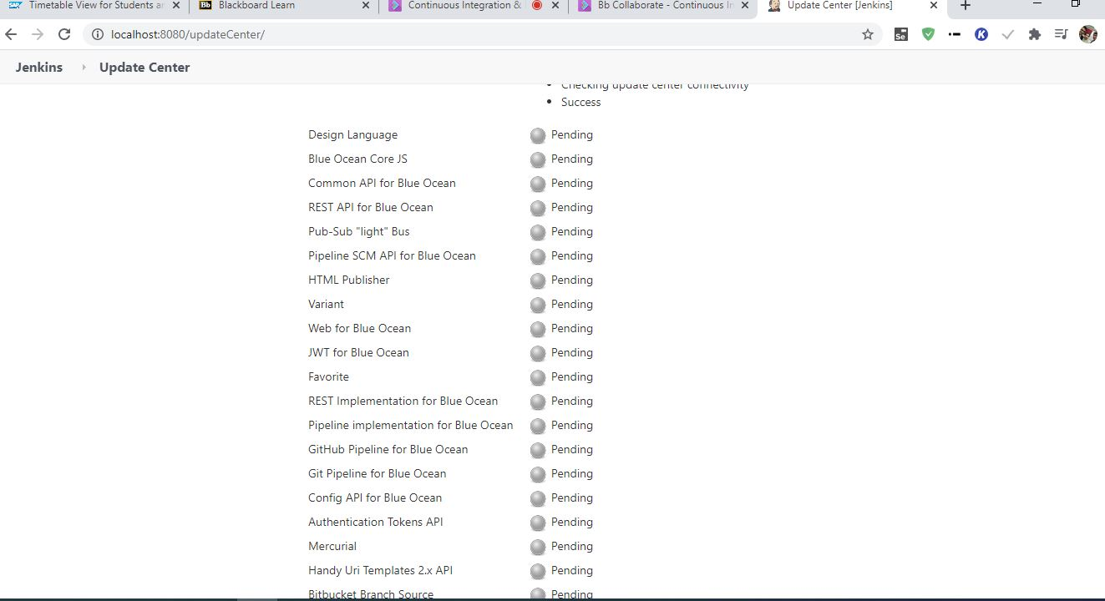

**Step-3:** Click on Open Blue Ocean and create new pipeline. Connect it with GitHub. Choose the repository and click on Create pipeline.

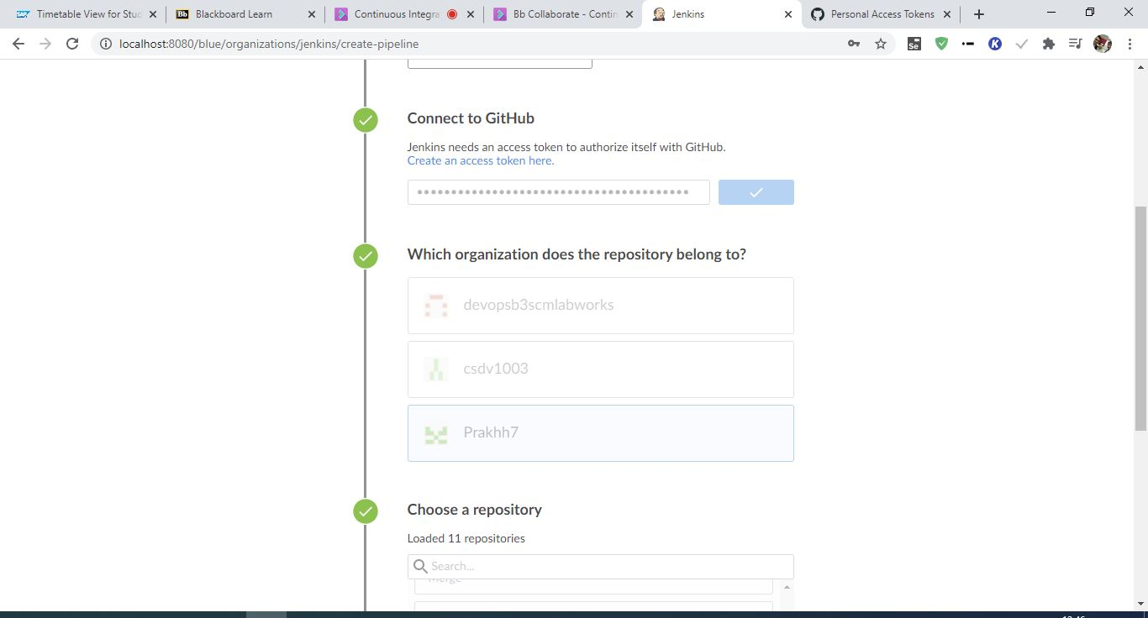

**Step-4:** Pipeline will be created.



